Northeastern University

College of Professional Studies

ALY6020 – Predictive Analytics

Spring 2020 CPS Quarter – First Half

Assignment: Function approximation with neural networks

# Goal

To approximate a two-variable function (shown below) to a high degree of accuracy

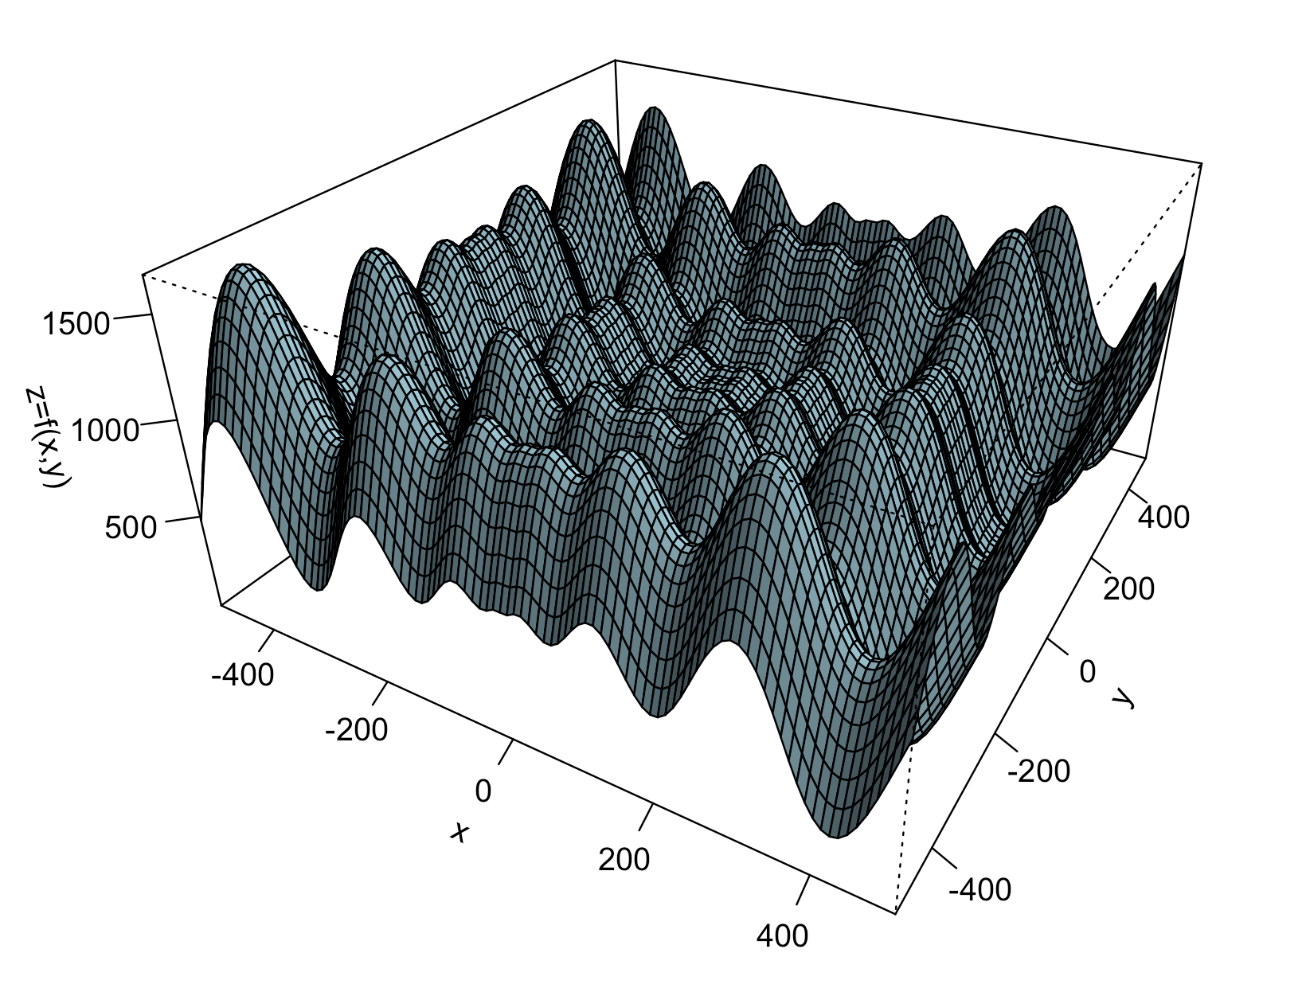

# Specific Instructions

Download the training and test set (it’s the same for this application) [here](https://drive.google.com/file/d/1cLw7TwRWRd_w7njvksiU0mHU44aCovx0/view?usp=sharing). This file has tuples of the form (x,y,z), where z=f(x,y). To plot the function, you can use the following code snippet:

dataset = read.table("NN3D_data.csv", sep =",", header = TRUE)

m <- length(unique(dataset$x))

n <- length(unique(dataset$y))

nz <- matrix(dataset$z, nrow=m, ncol=n, byrow = FALSE)

persp(unique(dataset$x),unique(dataset$x),nz,theta=30, phi=30, expand=0.5,col="lightblue", zlab="z=f(x,y)", xlab = "x", ylab = "y", ticktype="detailed", shade=.75, lphi=45, ltheta=135)

Use the code we saw in class to train a feedforward neural network with two inputs in the input layer, and one neuron in the output layer. The number of hidden layers, and the type of neurons is left to you to experiment with. Report your experiments and the best solution you could find.